**X-CALI**



**Final Report**

*“Design of Robots Collaboratively Carrying a Long Object Through an Open-Top Maze”*

Submitted to: Ali Özgür Yılmaz

Date of Submission: May 11, 2018

**Company Shareholders**

Oytun Akpulat 2093201 [oytun.akpulat@metu.edu.tr](mailto:oytun.akpulat@metu.edu.tr)

Göksenin Hande Bayazıt 2093441 [hande.bayazit@metu.edu.tr](mailto:hande.bayazit@metu.edu.tr)

Emre Doğan 2093656 [dogan.emre@metu.edu.tr](mailto:dogan.emre@metu.edu.tr)

Taha Doğan 2093672 [taha.dogan@metu.edu.tr](mailto:taha.dogan@metu.edu.tr)

Burak Sezgin 2094456 [burak.sezgin@metu.edu.tr](mailto:burak.sezgin@metu.edu.tr)

Table of Contents

Executive Summary 3

Introduction 4

Design Descriptions 5

Technical Details 6

Mechanic Design 6

Movement 7

Detection 7

Plank Placement 7

Modification to Critical Design 7

Requirement Analysis 8

Test and Subsystem Evaluation 9

Movement of the Robot 9

Detection of Plank 10

Power 10

Safety Issues 10

Organizational Plan 10

Application of the Product 11

List of Deliverables 11

Cost Analysis 11

Conclusion 12

References 13

Appendices 13

Appendix XXXxxxxxX, Movement Test Results 13

Appendix XXXX 16

List 16

User Manual 17

# Executive Summary

The X-Cali company was founded by five shareholders at September 2017. All of the shareholders are qualified senior Electrical & Electronics Engineering students. The main interests of the X-Cali are research, development and producing useful products for the customers. Customer satisfaction is the most important concern of the X-Cali.

For the shareholders of the X-Cali, the ‘Maze Solving Robots’ project has been a great experience. We learnt a lot about electrical and electronics engineering applications. We tried to go beyond our limits and do our best for this project. Different solution approaches were discussed and after all the work we performed, we came up with a final innovative solution.

In today’s world, efficiency is everything and we are aware of this fact. We believe that we did our best and created the most efficient robot that is possible in every aspect.

For all of us, this team work was the first one we experience and it will be very useful in our professional career since probably we will work as team members in the future.

To sum up, we think that we did our best and produced a robot that is useful and easy to use. We are happy with our product and sure that customers will be happy too. We hope that we will continue to research and development processes and to produce innovative products.

# Introduction

At the beginning of our last year, we formed a project group as five senior Electrical & Electronics Engineering students and this was where our adventure started. Choosing a project was the first step of the project process. At September, we started to think about which project to choose. We had to consider all the important parameters and make a choice accordingly. Detailed researches were done. After long discussions, we chose the ‘Maze Solving Robot’ project. In this project, two robots are supposed to collaboratively carry a plank through an open-top maze.

After the choice was made, we began to research process. Firstly, we conducted a research about which components to use at the construction of the project. There were a lot of options and we had to be cautious. Once the component decisions were made, our second concern were the algorithms those will determine the movement of the robots. Again a research was conducted and we started to work on the several solutions. Until the end of the first semester, we continued to work on algorithms theoretically and implemented a robot that would be used temporarily for the first demo.

At the spring semester, we worked on both software and hardware parts of the project. A prototype of the robot was constructed and test procedure was started. After several tests, we evaluated the results and made some changes on the robot. Towards the end of the semester, we had two demonstrations to our Design Studio Coordinator. After those demonstrations, we were ready for the final demonstration.

In conclusion, the whole project process had been a good experience for us. We tried to explain our design and implementation of the project in this report. We hope that it will be useful for our customers.

# Design Descriptions

This project aims to build a robot that can collaboratively carry an object with another robot in an open-top maze. This duty’s main requirements are designing a robot which is aware of its surrounding and which can freely, predictably and precisely move. To achieve this purpose, we have designed and built the robot in three main subsystems according to their functions. The robot includes a body part, which is the main chassis and passive components on it, a detection part that is composed of a camera, proximity sensors and algorithms that provides surrounding awareness, and finally movement part with motor drive system, tires and movement control algorithms. Detailed block diagrams and flowcharts of these subsystems of the robot are provided on Figures XXXXXX1 and XXXXX2 below.

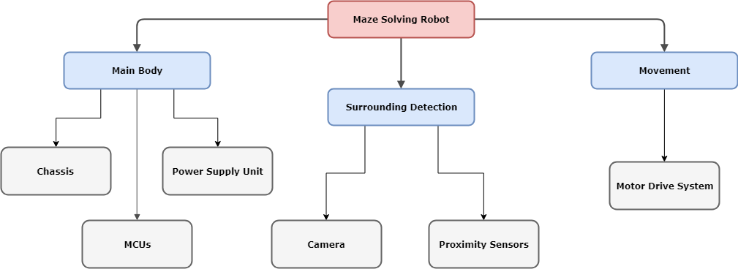

Figure XXXXXX1: Block Diagram of the Overall System

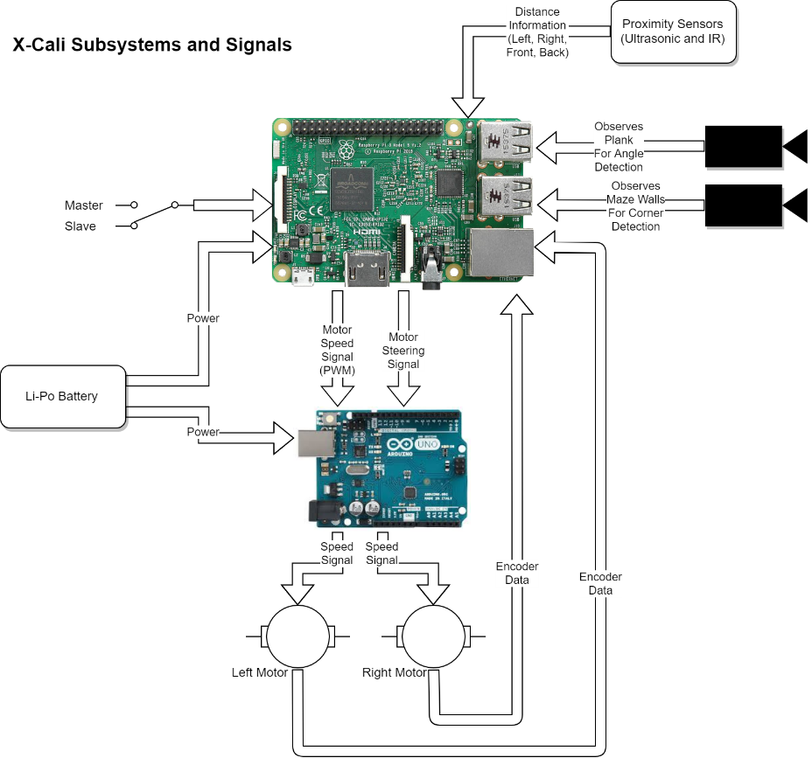

Figure XXXXXX2: Flowchart of the System Functioning

# Technical Details

## Mechanic Design

Robot is design in a circular shape. This is the most applicable geometry in the maze in order to prevent obstruction. Circular shape provides flexibility to robot for continuing its path after contact with the wall. Although RaspberryPi does not fit perfectly to the robot, it is still the best solution for chassis design. The robot has a diameter of 100mm. By making the robot that small, it can travel in the maze easily by polling the distances between the two walls. The procedure is given under Movement. There are three layers. In the first layer, the motor driver and side wall sensors are located. In the second layer, RaspberryPi and front wall sensor are placed. On the top layer, battery and power bank is located. Using the advantage of connections of layers, we build the camera holders on top of them.

BURAYA FOTO KOYUP PARAGRAFI AZ DAHA DETAYLANDIR!!!!!!!!!!!!!!!!!!!!!!

## Movement

The robot proceeds through maze using Bang-Bang algorithm. Bang-Bang algorithm is simply proportional feedback system. It takes the distances from the sides as inputs. The width of the road is given initially. Using these data, it tries to stay at the middle of the street. The proportional constant is tuned by experimenting the robot behavior in the maze. Since the robot is small – actually we made it smaller than the one in out critical design report, it can align itself easily.

## Detection

## Plank Placement

The constriction on plank placement was declared in the Standard Committee Report. Between the two hole there is 400mm distance and the holes are with 10mm diameter. The important point of plank placement is, every group must be able to use the other group’s plank too. When this case is considered, we needed a generic solution. Thus, we came up with the idea of using a ball bearing whose outer diameter is 10mm and inner diameter is 3mm. 3mm of inner diameter provides us also efficiency in the usage of resources as in the other parts of the robot we also use 3mm screws. The plank is fixed using a screw and a ring nut. The plank fixation is showed in the Figure XXXXXXXXXXXX below.

Figure XXXXXXXXX: Plank fixation on the robot

# Modification to Critical Design

In the Critical Design Report, the design proposals are finalized. After the Critical Design Report, we did many improvement to our robot while staying in the borders of our proposals. The most significant design update is chassis of the robot. We ended critical design session with a two-layered 150mm x 150mm square chassis. Although, the robot was able to complete its travel through maze, as a precaution we designed a new three-layered chassis with a circular shape of 100 mm diameter. This update provided us more freedom in the maze and by this update; we are now able to observe the effects of Bang-Bang control more clearly.

Apart from the chassis update, we also continued improving the codes to solve the maze. Previously, we were using a code understands the upcoming turn type and calls the related code. In the new script, we wrote a generic code that applies all the turns except two special cases.

# Requirement Analysis

All the requirements decided in the standard committee are evaluated in the Table XXXXX.

**Table XXXXX: Requirement Analysis of the Project**

|  |  |  |
| --- | --- | --- |
| # OF STANDARD | PROJECT STANDARDS | STATUS |
| 1 | Color of the ground and walls should be white. | Satisfied |
| 2 | Height of walls should be100 mm. | Satisfied |
| 3 | Upper side of walls (between 90mm height – 100mm height) should be black. | Satisfied |
| 4 | Top of every wall pieces should have 1 cm width and should be black. | Satisfied |
| 5 | Plank should have 3 mm thickness, 50 mm width and 500 mm length. | Satisfied |
| 6 | Color of the plank should be red and material of plank should be hardboard. | Satisfied |
| 7 | Shape of the holding point should be circle. Diameter of this circle should be10mm. Length between centers of the holes is 400 mm. | Satisfied |
| 8 | Robots of companies should fit into a square. This square has a 23cm side length. | Satisfied |
| 9 | Height of the holding point should be 17cm. | Satisfied |
| 11 | The maze should be modular and reconfigurable. In other words, walls can be removed or added on the platform. | Satisfied |
| 12 | Every team should design their own robot, maze and plank | Satisfied |
| 13 | Every robot should be able to operate in each other’s maze and each other’s plank. | Not satisfied yet |
| 14 | If the state changes, robots should behave accordingly. | Satisfied |
| 15 | Robots should move respect to right wall. | Satisfied |
| 16 | The total cost of the project must be less than 200 USD. | Satisfied |

# Test and Subsystem Evaluation

## Movement of the Robot

Movement tests of the robot have been performed since the first implementation stage of robot. With the feedback of several errors encountered, the movement performance of the robot has increased day by day. With the final implemented version of the robot, the movement tests were passed successfully.

In the first implemented robot chassis, a motor driving algorithm was not used. Instead, we used direct driving in a basic way. In that stage, this application was adequate to follow the straight road. But when the turning algorithms were implemented, significant problems regarding to the driving algorithm appeared. At that stage, Bang-Bang algorithm was preferred and implemented as the driving algorithm of the robot.

The logic behind this algorithm is to switch abruptly between two states, which is in our scenario turning left and right. This type of controller algorithm is also known as the hysteresis controller algorithm.

After implementing this type of controller, some modifications were done to increase the stability of the robot while making turns in the maze.

Some test results regarding to our latest updated controller algorithm can be found in Appendix XX.

## Detection of Plank

## Power

In our robot, there are two types of power suppliers. One of them is Li-Po Battery, supplies energy for wheels, and the other one is power bank, which supplies energy for Raspberrypi3. Since there is no component that sinks power dramatically, voltage and current concerns is not crucial for our design. The Li-Po Battery can serve more than 1.5 hours with full performance.

# Safety Issues

* Li-Po Batteries in the robot may explode or start a fire or release poisonous gases during usage of the robot.
* Li-Po batteries may explode or start a fire or release poisonous gases during charging them.
* Overheating of microcontrollers may cause burns on the skin.

# Organizational Plan

Figure XXXXXXX: Organizational Structure of X-Cali

# Application of the Product

X-Calibot is a product to be used in many fields where there is a necessity of carrying long & heavy loads.

In the last decade, the online shopping became the most preferred way to buy or sell items. This situation brought the necessity of having very large sized warehouses for these e-shopping companies. As the size of these warehouses became larger and larger, the necessity of more workers in these places increased. But this leads to employ more workers and decreases efficiency. So, X-Calibot brings a safe and cheap way to carry long and heavy loads within these warehouses. So that, the carrying operation can be done without employing large number of workers.

Another application of the product is in the defense industry. There are many companies producing weapons (especially long rifles), missiles and rockets all around the world. These products are too heavy for people to carry. And also, it is too dangerous for people to carry such products with the risk of high explosibility. X-Calibot offers a much safer and easier way to carry these products. In the plank region of the X-Calibot, there is a box that each type of product can be placed to be transmitted to the desired position.

# List of Deliverables

List of deliverables, including User Manual, is given in the Appendix XXXXXX

# Cost Analysis

In the Table XXXXXXX, cost analysis of the final product is given.

**Table XXXXXX: Cost Analysis of the Project**

|  |  |  |  |
| --- | --- | --- | --- |
| **Product Name** | **Price / Product** | **Quantity** | **Total Price** |
| Raspberry Pi 3 | ₺181.65 | 1 | ₺181.65 |
| HC-SR04 Arduino Ultrasonic Distance Sensor | ₺5.50 | 4 | ₺22.00 |
| Webcam | ₺20.00 | 2 | ₺40.00 |
| Motors | ₺40.00 | 2 | ₺80.00 |
| L298N Motor Driver | ₺12.00 | 1 | ₺12.00 |
| Mad wheel | ₺5.00 | 2 | ₺10.00 |
| Robot Chassis | ₺15.00 | 1 | ₺15.00 |
| Jumper Cables | ₺5.00 (/set) | 2 | ₺10.00 |
| 11.1V 1300mA LIPO Battery | ₺69.50 | 1 | ₺69.50 |
| LIPO Battery Charger | ₺45.00 | 1 | ₺45.00 |
| Power Bank 5000MAH |  |  | ₺60,00 |
| 24V-5V 3A DC to DC USB Power Module | ₺6.65 | 1 | ₺6.65 |
| Screw set | ₺30.00 | 1 | ₺30.00 |
| Plank and ball bearings | ₺20.00 | 1 | ₺20.00 |
| Maze construction |  |  | ₺150.00 |
|  |  | **TOTAL PRICE** | ₺751,80 |

Please note that, we were allowed to spend up to $200,-. Total price is, according to today’s currency, $177, 59.

# Conclusion

This final report was prepared by members of the X-Cali in order to inform the customers about the design and construction processes of the product. Circuit diagrams, flow charts that explain subsystems, test and subsystem evaluation, result of the performance tests and cost analysis are provided.

Our solution approach for angle detection was also explained in this report. The solution includes two cameras and image processing. Angle of the plank will be determined with the data coming from camera. After that angle data will be processed in RaspberryPi.

Ultimate goal of X-Cali is to become a valuable company in the electronics market in the world. We will work hard for this purpose and we hope that we will succeed.

In conclusion, we can state that our robot is ready except small modifications. Some minor modifications may be done. When the final version of our robot is available, we believe that people will be highly interested in our robot.

# References

# Appendices

## Appendix XXXxxxxxX, Movement Test Results

**1. Going through a straight line by itself**

In this test, the robot is supposed to enter a straight maze corridor and leave it successfully.

We applied this test 15 times and according to our observations, the robot completed the trials with 87% success rate. There are 2 unsuccessful attempts in which the bang-bang controller failed.

**2. Making the L turn by itself**

In this test, the robot is supposed to complete a L turn itself. For this purpose, we use the data coming from the ultrasound sensors.

On the real maze platform, we applied this test 15 times. 13 of these trials were successful. Reasons leading these errors can be seen from the Table 1.

|  |  |
| --- | --- |
| **HIT/FAIL?, Error Type** | **Frequency** |
| Detected the wall and made the L turn. But due to excessive turning (about 120o), it failed. | 1 |
| Everything worked fine. But the cables within the chassis mislead the ultrasound sensors. | 1 |
| Everything worked fine. | 13 |

Table 1. Different Situations Occurred During the L turn tests.

**3. Making the U turn by itself**

In the U turn tests, a process similar to the L turn was followed and the results can be observed below in Table 2.

|  |  |
| --- | --- |
| **HIT/FAIL?, Error Type** | **Frequency** |
| Detected the wall and made the first L turn. But due to excessive turning it had problems in the second L turn. | 2 |
| It successfully completed the U turn. But after the turn, it had problems on straight path movement. | 1 |
| Everything worked fine. | 12 |

Table 2. Different Situations Occurred During the U turn tests.

**3. Making the L Turn with Plank**

**a. Master Robot**

|  |  |
| --- | --- |
| **HIT/FAIL?, Error Type** | **Frequency** |
| Detected the wall and made the stop to indicate the stop. But it approached to the wall more than it should be. So the slave robot cannot turn successfully. | 8 |
| It successfully completed the L turn. | 7 |

Table 3. Different Situations Occurred During the L turn tests.

**b. Slave Robot**

|  |  |
| --- | --- |
| **HIT/FAIL?, Error Type** | **Frequency** |
| Could not detect the stop. But it continued to go. | 8 |
| It successfully completed the L turn. | 7 |

Table 4. Different Situations Occurred During the L turn tests.

## Appendix XXXX

### List

The first robot of X-Cali is designed for general usage. There is no specific client profile for our product. The robot can be used for different purposes such as gaming or educational purposes.

The expected deliverables of the work packages of our project can be seen in Table.

**Table 5: Expected Deliverables of the Work Packages of the Project**

|  |  |  |
| --- | --- | --- |
| **The Work Package** | **Corresponding Deliverable** | **Status** |
| Research | Tentative Report | Completed |
| Component Tests | Results and analysis of the component test | Completed for the ultrasonic sensors and RP3. Test plan is achieved. |
| Communications Subsystem  Design | Results of the procedure of receiving& processing data | Not completed. |
| Mechanical Subsystem Design | Driving tests and analysis of the robot | Completed. Test plan is achieved. |
| Software Subsystem Design | Documentation of the algorithms and debugging results | Started but not completed. |
| Overall System Implementation & Tests | A robot completing the labyrinth by itself | Not completed yet. |
| Demonstration | A robot completing the labyrinth collaboratively with the other groups. The product within its package. | Not completed. |

The package of our product will include the main body of the robot, a plank, user manual, two spare tires, a backup battery and a remote controller deciding the robot to become master or slave.

The size of the robot can be adjusted according to the customers’ demands. The product will be prepared in 10 weekdays after the order. Users can find all the necessary information about the product in the user manual.

You can contact us via our web site <http://www.xcali.ml>.

### User Manual

**WHAT’S IN THE BOX?**

* X-Calibot
* 11.1 V LiPo battery
* 5000 mAh powerbank
* USB cable
* Wooden plank
* User manual

**GETTING STARTED WITH YOUR X-CALIBOT**

1. Connect the powerbank to RaspberryPi.
2. Make sure that green and red LED’s on RaspberryPi blink.
3. Connect the LiPo battery to the same colored supply terminals of motor driver.
4. Couple the wooden plank to the holding point on top of X-Calibot.
5. Choose the playing mode (master or slave) by using the switch on top of X-Calibot.
6. Place your X-Calibot in a maze.
7. Enjoy!

**WARNINGS**

* X-Calibot is not suitable for use of children under 5 years old. Keep X-Calibot out of reach of children under 5 years old.
* Do not use your X-Calibot for longer than 3 hours. Charge the LiPo battery immediately after having used it. Undervoltaged batteries may explode and may be harmful.
* In case you notice a thickening on your battery, stop running your X-Calibot, disconnect the battery and contact X-Cali Customer Care.
* Make sure that you have connected the terminals of the battery correctly, polarity reversal may ruin your X-Calibot.
* Do not leave the plank on the holding point of your X-Calibot while not running it. Weight of the plank may be harmful for your device.
* In case you notice smoke or burning smell while running your X-Calibot, immediately disconnect the battery and the powerbank and contact X-Cali Customer Care.

**DISCLAIMER**

X-Calibot is produced, calibrated and tested under room conditions and white fluorescent light. X-Cali Inc. do not accept any responsibilities for any kind of malfunctionings of X-Calibot caused by operation under any other enviromental conditions.

Power supply units of X-Calibot are designed and produced specifically for X-Calibot. Any power supply units other than box content are not suitable for X-Calibot. X-Cali Inc. do not accept any responsibilites for possible damages on X-Calibot caused by different power supply units.

Using guide of device is clearly described in User Manual. X-Cali Inc. do not accept any responsibilites for possible damages on X-Calibot caused by user error.

In case of any ambiguity, please contact X-Cali Customer Care.